**Attach eni to instance**

Before we are able to perform this we need to create the management and backup ip. The rationale behind the management ip and attaching it to the instance is to allow accessing the server from **cyberark**. Next, we need to attach the backup ip to the instance which act as a **BAAS** which we will be accessing via **ITSM.**

**Creation of backup and management eni.**

Before we are able to create a eni, we need to create the security group.

**backup eni security group**

terraform {

    source = "git::git@sgts.gitlab-dedicated.com:wog/mha/ica-e-services/ica_common_services/app/gccplus_modules.git//tg-modules//secgrp"

}

include "root" {

    path = find_in_parent_folders()

}

locals {

    zone_vars        = read_terragrunt_config(find_in_parent_folders("zone.hcl"))

    regzone_vars     = read_terragrunt_config(find_in_parent_folders("regzone.hcl"))

    dlzzone_vars     = read_terragrunt_config(find_in_parent_folders("dlzzone.hcl"))

    proj_vars        = read_terragrunt_config(find_in_parent_folders("common.hcl"))

    app_vars         = read_terragrunt_config(find_in_parent_folders("app.hcl"))

    proj_code        = local.proj_vars.locals.proj_code

    app_name         = local.app_vars.locals.app_name

    vpc_id           = local.zone_vars.locals.vpc_id

    s3_prefix_list   = local.zone_vars.locals.s3_prefix_list

    cidr_block       = local.regzone_vars.locals.cidr_block

    vpc_subnets_cidr = local.dlzzone_vars.locals.vpc_subnets_cidr

    vpc_subnets_cidr_reg = local.regzone_vars.locals.vpc_subnets_cidr

    patchrepo        = local.zone_vars.locals.patchrepo

    bckp_mediasvr    = local.zone_vars.locals.bckp_mediasvr

    bckp_mstrsvr     = local.zone_vars.locals.bckp_mstrsvr

    eps_cidr         = local.zone_vars.locals.eps_cidr

    nessus_cidr      = local.zone_vars.locals.nessus_cidr

    custom_name         = local.app_vars.locals.custom_name

    inbound_rules = concat(

      [for cidr in local.patchrepo : [cidr, "443", "443", "tcp", "Traffic from BaaS Patch Repo"]],

      [for cidr in local.patchrepo : [cidr, "4120", "4120", "tcp", "Traffic from BaaS Patch Repo"]],

      [for cidr in local.bckp_mediasvr : [cidr, "1556", "1556", "tcp", "Traffic from BaaS"]],

      [for cidr in local.bckp_mediasvr : [cidr, "13724", "13724", "tcp", "Traffic from BaaS"]],

      [for cidr in local.bckp_mediasvr : [cidr, "13782", "13782", "tcp", "Traffic from BaaS"]],

      [for cidr in local.bckp_mstrsvr : [cidr, "1556", "1556", "tcp", "Traffic from BaaS"]],

      [for cidr in local.bckp_mstrsvr : [cidr, "13724", "13724", "tcp", "Traffic from BaaS"]],

      [for cidr in local.bckp_mstrsvr : [cidr, "13782", "13782", "tcp", "Traffic from BaaS"]],

      [for cidr in local.eps_cidr : [cidr, "443", "443", "tcp", "Traffic from eps "]],

      [for cidr in local.eps_cidr : [cidr, "4118", "4122", "tcp", "Traffic from eps"]],

    )

    outbound_rules = concat(

      [for cidr in local.patchrepo : [cidr, "443", "443", "tcp", "Traffic from BaaS Patch Repo"]],

      [for cidr in local.patchrepo : [cidr, "4120", "4120", "tcp", "Traffic from BaaS Patch Repo"]],

      [for cidr in local.bckp_mediasvr : [cidr, "1556", "1556", "tcp", "Traffic from BaaS"]],

      [for cidr in local.bckp_mediasvr : [cidr, "13724", "13724", "tcp", "Traffic from BaaS"]],

      [for cidr in local.bckp_mediasvr : [cidr, "13782", "13782", "tcp", "Traffic from BaaS"]],

      [for cidr in local.bckp_mstrsvr : [cidr, "1556", "1556", "tcp", "Traffic from BaaS"]],

      [for cidr in local.bckp_mstrsvr : [cidr, "13724", "13724", "tcp", "Traffic from BaaS"]],

      [for cidr in local.bckp_mstrsvr : [cidr, "13782", "13782", "tcp", "Traffic from BaaS"]],

      [for cidr in local.eps_cidr : [cidr, "443", "443", "tcp", "Traffic from eps "]],

      [for cidr in local.eps_cidr : [cidr, "4118", "4122", "tcp", "Traffic from eps"]],

      [[local.nessus_cidr, "8834", "8834", "tcp", "nessus"]]

    )

}

inputs = {

  vpc_id = local.vpc_id

  app_name = "${local.app_name}-${local.custom_name}"

  sg_description = "Security group for ${local.app_name}"

  inbound_rules  = zipmap(range(length(local.inbound_rules)), local.inbound_rules)

  outbound_rules = zipmap(range(length(local.outbound_rules)), local.outbound_rules)

  pf_inbound_rules = {

        "0" = [local.s3_prefix_list, "443", "443", "TCP"]

    }

  pf_outbound_rules = {

        "0" = [local.s3_prefix_list, "443", "443", "TCP"]

    }

}

backup eni

terraform {

    source = "git::git@sgts.gitlab-dedicated.com:wog/mha/ica-e-services/ica_common_services/app/gccplus_modules.git//tg-modules//eni"

}

include "root" {

    path = find_in_parent_folders()

}

dependency secgrp {

    config_path = "../secgrp"

}

locals{

    zone_vars        = read_terragrunt_config(find_in_parent_folders("zone.hcl"))

    bckp_subnet_cidr = local.zone_vars.locals.bckp_subnet_cidr

    bckp_subnet_id   = local.zone_vars.locals.bckp_subnet_id

}

inputs = {

    eni = {

        0 = {

            subnet_id       = local.bckp_subnet_id[0]

            private_ips     = [cidrhost(local.bckp_subnet_cidr[0],13)],

            security_groups = [dependency.secgrp.outputs.sg_id],

        }

        1 = {

            subnet_id       = local.bckp_subnet_id[1]

            private_ips     = [cidrhost(local.bckp_subnet_cidr[1],13)]

            security_groups = [dependency.secgrp.outputs.sg_id]

        }

    }

}

# management eni security group

terraform {

    source = "git::git@sgts.gitlab-dedicated.com:wog/mha/ica-e-services/ica_common_services/app/gccplus_modules.git//tg-modules//secgrp"

}

include "root" {

    path = find_in_parent_folders()

}

locals {

    zone_vars        = read_terragrunt_config(find_in_parent_folders("zone.hcl"))

    regzone_vars     = read_terragrunt_config(find_in_parent_folders("regzone.hcl"))

    dlzzone_vars     = read_terragrunt_config(find_in_parent_folders("dlzzone.hcl"))

    proj_vars        = read_terragrunt_config(find_in_parent_folders("common.hcl"))

    app_vars         = read_terragrunt_config(find_in_parent_folders("app.hcl"))

    proj_code        = local.proj_vars.locals.proj_code

    app_name         = local.app_vars.locals.app_name

    vpc_id           = local.zone_vars.locals.vpc_id

    s3_prefix_list   = local.zone_vars.locals.s3_prefix_list

    cidr_block       = local.regzone_vars.locals.cidr_block

    vpc_subnets_cidr = local.dlzzone_vars.locals.vpc_subnets_cidr

    vpc_subnets_cidr_reg = local.regzone_vars.locals.vpc_subnets_cidr

    patchrepo        = local.zone_vars.locals.patchrepo

    bckp_mediasvr    = local.zone_vars.locals.bckp_mediasvr

    bckp_mstrsvr     = local.zone_vars.locals.bckp_mstrsvr

    eps_cidr         = local.zone_vars.locals.eps_cidr

    nessus_cidr      = local.zone_vars.locals.nessus_cidr

    custom_name      = local.app_vars.locals.custom_name

    gdc_cidr         = local.zone_vars.locals.gdc_cidr

    inbound_rules = concat(

      [for cidr in local.patchrepo : [cidr, "443", "443", "tcp", "Traffic from BaaS Patch Repo"]],

      [for cidr in local.patchrepo : [cidr, "4120", "4120", "tcp", "Traffic from BaaS Patch Repo"]],

      [for cidr in local.bckp_mediasvr : [cidr, "1556", "1556", "tcp", "Traffic from BaaS"]],

      [for cidr in local.bckp_mediasvr : [cidr, "13724", "13724", "tcp", "Traffic from BaaS"]],

      [for cidr in local.bckp_mediasvr : [cidr, "13782", "13782", "tcp", "Traffic from BaaS"]],

      [for cidr in local.bckp_mstrsvr : [cidr, "1556", "1556", "tcp", "Traffic from BaaS"]],

      [for cidr in local.bckp_mstrsvr : [cidr, "13724", "13724", "tcp", "Traffic from BaaS"]],

      [for cidr in local.bckp_mstrsvr : [cidr, "13782", "13782", "tcp", "Traffic from BaaS"]],

      [for cidr in local.eps_cidr : [cidr, "443", "443", "tcp", "Traffic from eps "]],

      [for cidr in local.eps_cidr : [cidr, "4118", "4122", "tcp", "Traffic from eps"]],

      [for cidr in local.gdc_cidr : [cidr, "22", "22", "tcp", "Traffic from bedok"]],

      [for cidr in local.gdc_cidr : [cidr, "135", "135", "tcp", "Traffic from bedok"]],

      [for cidr in local.gdc_cidr : [cidr, "139", "139", "tcp", "Traffic from bedok"]],

      [for cidr in local.gdc_cidr : [cidr, "443", "443", "tcp", "Traffic from bedok"]],

      [for cidr in local.gdc_cidr : [cidr, "445", "445", "tcp", "Traffic from bedok"]],

      [for cidr in local.gdc_cidr : [cidr, "3389", "3389", "tcp", "Traffic from bedok"]],

    )

    outbound_rules = concat(

      [for cidr in local.patchrepo : [cidr, "443", "443", "tcp", "Traffic from BaaS Patch Repo"]],

      [for cidr in local.patchrepo : [cidr, "4120", "4120", "tcp", "Traffic from BaaS Patch Repo"]],

      [for cidr in local.bckp_mediasvr : [cidr, "1556", "1556", "tcp", "Traffic from BaaS"]],

      [for cidr in local.bckp_mediasvr : [cidr, "13724", "13724", "tcp", "Traffic from BaaS"]],

      [for cidr in local.bckp_mediasvr : [cidr, "13782", "13782", "tcp", "Traffic from BaaS"]],

      [for cidr in local.bckp_mstrsvr : [cidr, "1556", "1556", "tcp", "Traffic from BaaS"]],

      [for cidr in local.bckp_mstrsvr : [cidr, "13724", "13724", "tcp", "Traffic from BaaS"]],

      [for cidr in local.bckp_mstrsvr : [cidr, "13782", "13782", "tcp", "Traffic from BaaS"]],

      [for cidr in local.eps_cidr : [cidr, "443", "443", "tcp", "Traffic from eps "]],

      [for cidr in local.eps_cidr : [cidr, "4118", "4122", "tcp", "Traffic from eps"]],

      [[local.nessus_cidr, "8834", "8834", "tcp", "nessus"]]

    )

}

inputs = {

  vpc_id = local.vpc_id

  app_name = "${local.app_name}-${local.custom_name}"

  sg_description = "Security group for ${local.app_name}"

  inbound_rules  = zipmap(range(length(local.inbound_rules)), local.inbound_rules)

  outbound_rules = zipmap(range(length(local.outbound_rules)), local.outbound_rules)

  pf_inbound_rules = {

        "0" = [local.s3_prefix_list, "443", "443", "TCP"]

    }

  pf_outbound_rules = {

        "0" = [local.s3_prefix_list, "443", "443", "TCP"]

    }

}

management eni

terraform {

    source = "git::git@sgts.gitlab-dedicated.com:wog/mha/ica-e-services/ica_common_services/app/gccplus_modules.git//tg-modules//eni"

}

include "root" {

    path = find_in_parent_folders()

}

dependency secgrp {

    config_path = "../secgrp"

}

locals{

    zone_vars         = read_terragrunt_config(find_in_parent_folders("zone.hcl"))

    mgmt_subnet_cidr  = local.zone_vars.locals.mgmt_subnet_cidr

    mgmt_subnet_id    = local.zone_vars.locals.mgmt_subnet_id

}

inputs = {

    eni = {

        0 = {

            subnet_id       = local.mgmt_subnet_id[0]

            private_ips     = [cidrhost(local.mgmt_subnet_cidr[0],13)],

            security_groups = [dependency.secgrp.outputs.sg_id],

        }

        1 = {

            subnet_id       = local.mgmt_subnet_id[1]

            private_ips     = [cidrhost(local.mgmt_subnet_cidr[1],13)]

            security_groups = [dependency.secgrp.outputs.sg_id]

        }

    }

}

Once we have created the backup and management eni, we will attached it via script.

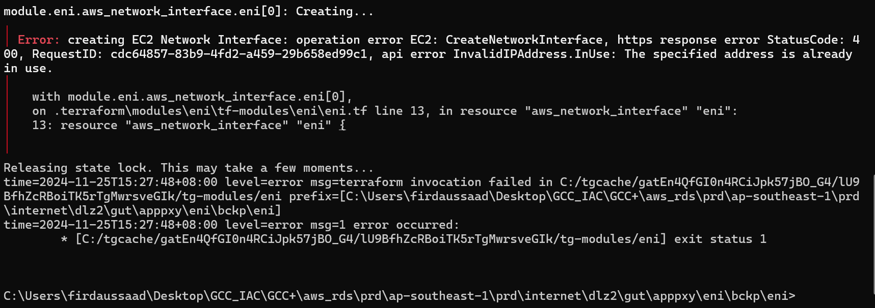

If we got this error, this shows the eni has been taken and created. To resolved this we just need to use a higher number.

eni_mgmt=("<eni_mgmt_ip")

                       eni_bckp=("eni_bckp_ip")

                       TOKEN=`curl -X PUT "http://169.254.169.254/latest/api/token" -H "X-aws-ec2-metadata-token-ttl-seconds: 21600"`

                       INSTANCE_ID=$(curl -H "X-aws-ec2-metadata-token: $TOKEN" -v http://169.254.169.254/latest/meta-data/instance-id)

                       EC2_AVAIL_ZONE=$(curl -H "X-aws-ec2-metadata-token: $TOKEN" -v http://169.254.169.254/latest/meta-data/placement/availability-zone |  awk '{print $1}')

                       echo $INSTANCE_ID

                       echo $EC2_AVAIL_ZONE

                       aws ec2 attach-network-interface --region ap-southeast-1 --network-interface-id $eni_mgmt  --instance-id $INSTANCE_ID --device-index 1

                       aws ec2 attach-network-interface --region ap-southeast-1 --network-interface-id $eni_bckp  --instance-id $INSTANCE_ID --device-index 2

This is the [eni.sh](http://eni.sh) script. First we need to change eni_mgmt_ip and eni_bckp_ip. Next we shall also add the [eni.sh](http://eni.sh) to the userdata script.

Once we have made changes to [eni.sh](http://eni.sh), lets check the userdata script if it contains this set of commands as we aim to automate the process.

# Attach Backup & Mgmt IP

aws s3 --region ap-southeast-1 cp s3://${s3}/eni.sh /home/ec2-user/eni.sh

sudo dos2unix /home/ec2-user/eni01.sh

sudo chmod 755 /home/ec2-user/eni01.sh

/home/ec2-user/eni01.sh

Once we have done, lets perform a instance refresh.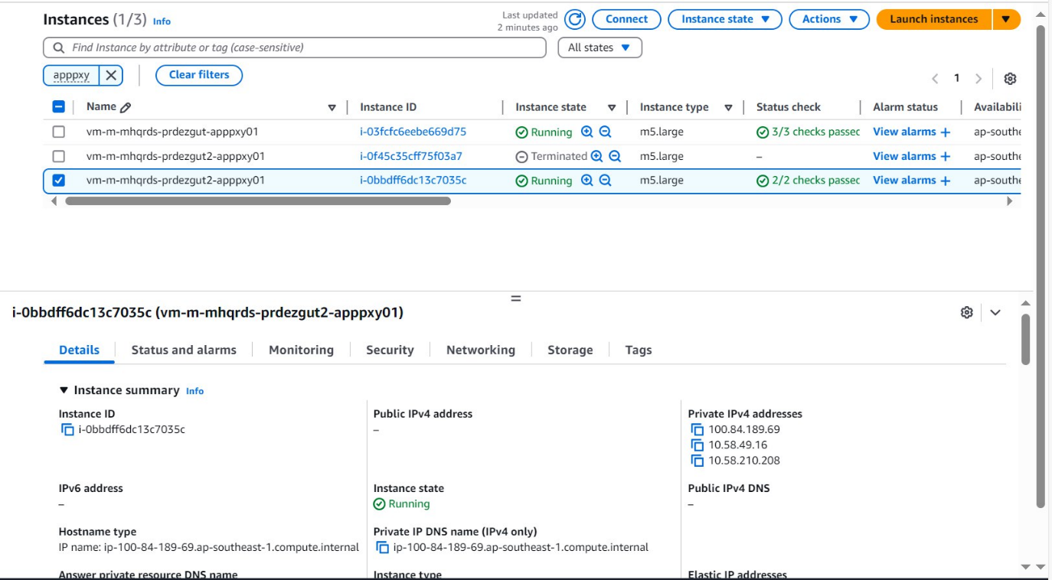

Ensure that we have open the ports we are required. To know we can run this command in the instance we want to attached the eni. This shows we are about to connect the ec2 endpoint.

curl -v https://ec2.ap-southeast-1.amazonaws.com

